**Chapter 5**

**Islamic Microfinance in Sudan: Strengths, Weaknesses, Opportunities and Threats**

**A Case Study of Agricultural Bank, and Saving & Social Development Bank**

**Bakhita Hamdow Gad Elkreem**

**Introduction**

Since the Grameen Bank and its founder Muhammad Yunus won the Nobel Peace Prize in 2006 for their innovations in poverty alleviation through microfinance, the world has witnessed a virtual “microfinance revolution.” Microcredit is the most common form of microfinance. Microcredit provides small (often group-based) loans to those who are impoverished and lack collateral. It has been credited for alleviating poverty and raising the incomes of millions of people in developing countries. Beginning with Yunus’s Grameen Bank in Bangladesh, microfinancing as both a development tool and a means for bringing social change has spread to other developing countries and has been adapted for use in impoverished areas in developed, high-income nations including the United States.

Microfinance include microcredit with other financial tools such as micro insurance and micro savings as well as the possibility of combining microfinance with other non-financial aspects such as healthcare, education, and environmental issues. This chapter focuses on microcredit in Sudan. The aim is to understand whether microcredit led to achievement of microfinance objectives, social enhancement, and poverty alleviation, and to investigate whether microcredit in Sudan abides by Islamic finance principles. In addition, this study seeks to identify the strengths, weaknesses, opportunities and threats of the microfinance sector, so as to help in supervision and management of Islamic microfinance institutions such that microcredit would be an appropriate tool for poverty alleviation in Sudan. The study begins with the basic concepts of microfinance, discusses the economic principles behind this unique form of credit rationing, and provided an overview of similarities between conventional microfinance and Islamic finance.

**Data collection**

**First:** Structured interviews were conducted with the lender institutions. These included questions about the size of micro loans as percentage of funds available to credit, and borrowers’ titles, so that the researcher would be able to distribute questionnaires to them. The interviews also included questions about microcredit model followed by the lenders, clauses of borrowing, repayment conditions, and collaterals. In addition, the interviews included questions about whether gender affects repayment, and about default risk and employees’ training.

**Second:** Structured questionnaire form consisting of two parts was constructed to collect the necessary data. The first part focuses on demographic information of the respondents which include gender, income, religious beliefs and practices, age, and occupation. The second parts deals with respondents’ beliefs and attitudes toward the Islamic microfinance, and their point of views about whether microfinance has affected positively their income and living standard. Also, this part included respondents’ suggestions about improving microcredit to be appropriate tool for alleviation of poverty. A total of 45 questionnaires were distributed to employees and 101 distributed to poor borrowers (beneficiaries).

**Third:** Secondary data about GDP was collected from annul reports published by the central bank of Sudan and the studied banks (Agricultural Bank, and Saving & Social Development Bank).

**Significance of the study**

This study discusses Islamic microfinance behavior in Sudan, and recommends how microcredit can be utilized in line with Islamic finance principles (enhancing social development) and microfinance objective (poverty alleviation). Also, it finds that Islamic microfinance in Sudan is not achieving Islamic finance principle of social development through GDP growth.

**Theoretical background**

**Microfinance concept**

Microfinance is a powerful poverty alleviation tool. It implies provision of financial services to poor and low-income people whose low economic standing excludes them from formal financial systems. Access to services such as credit, venture capital, savings, insurance, and remittance is provided on a micro-scale, thereby enabling participation of those with severely limited financial means. The provision of financial services to the poor helps to increase household income and economic security, build assets and reduce vulnerability; creates demand for other goods and services (especially nutrition, education, and health care); and stimulates local economies.

**Principles of microfinance**

The basic principle of microfinance, as succinctly expounded by Dr. Muhamad Yunus, the founder of Grameen Bank in Bangladesh and recipient of the Nobel Peace Prize in 2006, is that credit is a fundamental human right. The primary mission of microfinance is, therefore, to help poor people in assisting themselves to become economically independent. Credit or loan is given for self-employment and for financing additional income generating activities CGAP (Note: Consultative Group to Assist the Poor (CGAP) is a consortium of 31 public and private development agencies working together to expand access to financial services for the poor, referred to as microfinance.) has come up with 11 key principles of microfinance (Brigit Helms, 2006) based on decade-long consultations with its members and stakeholders. These are as follows:

1. Poor people need a variety of financial services, not just loans. In addition to credit, they want savings, insurance, and money transfer services.

2. Microfinance is a powerful tool to fight poverty. Poor households use financial services to raise income, build their assets, and cushion themselves against external shocks

3. Microfinance means building financial systems that serve the poor. Microfinance will reach its full potential only if it is integrated into a country’s mainstream financial system.

4. Microfinance can pay for itself, and must do so if it is to reach very large numbers of poor people. Unless microfinance providers charge enough to cover their costs, they will always be limited by the scarce and uncertain supply of subsidies from governments and donors.

5. Microfinance is about building permanent local financial institutions that can attract domestic deposits, recycle them into loans, and provide other financial services.

6. Microcredit is not always the answer. Other kinds of support may work better for people who are so destitute that they are without income or means of repayment.

7. Interest rate ceilings hurt poor people by making it harder for them to get credit. Making many small loans costs more than making a few large ones. Interest rate ceilings prevent microfinance institutions from covering their costs, and thereby choke off the supply of credit for poor people.

8. The job of government is to enable financial services, not to provide them directly. Governments can almost never do a good job of lending, but they can set a supporting policy environment.

9. Donor funds should complement private capital, not compete with it. Donor subsides should be temporary start-up support designed to get an institution to the point where it can tap private funding sources, such as deposits.

10. The key bottleneck is the shortage of strong institutions and managers. Donors should focus their support on building capacity.

11. Microfinance works best when it measures—and discloses—its performance. Reporting not only helps stakeholders judge costs and benefits, but it also improves performance. Microfinance institutions need to produce accurate and comparable reporting on financial performance (e.g., loan repayment and cost recovery) as well as social performance (e.g., number and poverty level of clients being served).

**Models of microfinance**

Microfinance operating along conventional lines has witnessed enormous growth during the last couple of decades. Microfinance institutions provide to the entrepreneurial poor financial services that are tailored to their needs and conditions. Good microfinance programs are characterized by small, usually short-term loans; streamlined, simplified borrower and investment appraisal; quick disbursement of repeat loans after timely repayment; and convenient location and timing of services. There are four model practices (Obaidullah, Mohammed, Khan Tariqullah, 2008), as follows:

**1. Grameen Bank model** (group model):

In this concept, individuals come together to form small groups and apply for financing. Members of these small groups are trained regarding the basic elements of the financing and the requirements they will have to fulfill in order to continue to have access to funding.

Funds are disbursed to individuals within the group after they are approved by other members in the group. Repayment of the financing is a shared responsibility of all of the group’s members. In other words, they share the risk. If one defaults, the entire group’s members face a setback. This is a basic but effectual credit scoring mechanism that may mean a provisional suspension from the program and therefore no access to financing for the group or other penalties.

Groups normally consist of five members, who guarantee each other’s loans. A number of variants of the model exist; but the key feature of the model is group-based and graduated financing that substitute’s collateral as a tool to mitigate default and delinquency risk.

**2. Village Bank model**

The model involves an implementing agency that establishes individual village banks with about 30 to 50 members and provides “external” capital for onward financing to individual members. Individual loans are repaid at weekly intervals over four months, at which time the village bank returns the principal with interest/profits to the implementing agency.

A bank repaying in full is eligible for subsequent loans, with loan sizes linked to the performance of village bank members in accumulating savings. Savings accumulated in a village bank is also used for financing. As a village bank accumulates sufficient capital internally, it graduates to become an autonomous and self-sustaining institution (typically over a three-year period).

**3. Credit Union (CU)**

A CU is based on the concept of mutuality. It is in the nature of non-profit financial cooperative owned and controlled by its members. CUs mobilize savings, provide loans for productive and provident purposes and have memberships which are generally based on some common bond. CUs generally relate to an apex body that promotes primary credit unions and provides training while monitoring their financial performance.

**4. Self-Help Groups (SHGs)**

Each SHG is formed with about 10 to 15 members who are relatively homogeneous in terms of income. An SHG essentially pools together its members’ savings and uses it for lending. SHGs also seek external funding to supplement internal resources. The terms and conditions of loans differ among SHGs, depending on the democratic decisions of members. Typical SHGs are promoted and supported by NGOs, but the objective (as with village banks) is for them to become self-sustaining institutions. Some NGOs act as financial intermediaries for SHGs, while others act solely as ‘social’ intermediaries seeking to facilitate linkages of SHGs with either licensed financial institutions or other funding agencies. The SHG model is a good platform for combining microfinance with other developmental activities (Conroy, 2003).

**Islamic principles**

1. Ban on interest (riba). (Note: Riba means and includes any increase over and above the principal amount payable in a contract obligation, not covered by a corresponding increase in labor, commodity, risk or expertise). Any level of interest is considered to be usurious and is prohibited. The Qur’an contains almost a dozen references to this fundamental prohibition against interest, and it is discussed often in the Hadith (Hadith are narrations originating from the words and deeds of the Prophet Mohammad). The Qur’an proclaims: "Allah (Allah is the standard Arabic word for God) hath permitted trade and forbidden usury." This fundamental prohibition is "unequivocal," and the Qur’an and early Islamic writings clearly consider riba a very serious offense. The Messenger of Allah cursed the one who devours riba, the one who pays it, the one who witnesses it, and the one who documents it (Richardson, Christopher F., 2006, p.125). He also defined riba as “Gold for gold, silver for silver, wheat for wheat, barley for barley, dates for dates, and salt for salt; like for like, hand to hand, in equal amounts; and any increase is riba” (El-Gamal, 2000, p.3).

Sometimes it is misunderstood that only a high rate of interest is prohibited and any normal charge on loans or debts does not come under the purview of prohibition. It is argued that a loan involves riba only if it carries the condition of doubling and redoubling, and the word “riba” refers only to usurious loans on which an excessive rate of interest is charged by the creditors, which entails exploitation. It is added that modern banking interest cannot be termed “riba” as the rate of interest is not excessive or exploitative. However, the argument is not tenable as per the tenets of the Qur’an. The Qur’an makes it very clear that in a loan transaction, and for that matter a trade transaction culminating in a debt contract, any addition chargeable to the principal amount is riba. The Qur’an says: “If you repent, then you have your principal only”. Believers have been ordered to give up whatever amount of riba is outstanding. Further, “rate” is a relative term and any rate will, over time, double and redouble the principal; hence, any addition over the amount of debt per se is prohibited, irrespective of the rate (Ayub, 2008, p.50).

**2. Ban on transactions/products with excessive uncertainty (gharar-maisir)**

In principle, uncertainty in contractual terms and conditions is not allowed. Intrinsically, the limitation on gharar is related to the Islamic prohibition on gambling (maisir). Unlike riba (which is an absolute prohibition) some level of risk remains a fundamental aspect of commercial life and risk allocation a necessary component of Islamic finance; only disproportionate risk, speculative trading and transactions meeting exceeding limitations are considered gharar. The key element of gharar is uncertainty (Richardson, 2006, p.127).

While riba is condemned in the Holy Qur’an, condemnation of gharar is supported by Hadith. In business terms, gharar means to undertake a venture blindly without sufficient knowledge or to undertake an excessively risky transaction, although minor uncertainties can be permitted when there is some necessity. In a general context, the unanimous view of the jurists held that, in any transaction, by failing or neglecting to define any of the essential pillars of contract relating to the consideration or measure of the object, the parties undertake a risk which is not indispensable for them. This kind of risk is deemed unacceptable and tantamount to speculation because of its inherent uncertainty. Speculative transactions with these characteristics are therefore prohibited (Algaoud, Latifa M., Lewis, Mervyn K., Mohammed, 2007, p.39).

The prohibition of maisir covers gambling and other games of chance, such as lotteries and betting on races. While general commercial risk is permissible, forms of speculation which are regarded as akin to gambling are prohibited. Speculative trades where there is little or no certainty as to the outcome, such as currency market speculation or investment in derivatives, are not permitted. Where the distinction between general commercial risk and speculation is not clear the commercial substance of a transaction will be analyzed. Whilst distinct concepts, there is some degree of overlap between gharar and maisir (Sandstad, Ben, Strom, Hagbarth, 2009).

**3. Principle of risk and profit sharing**

In Islamic finance, those who finance investment share a good part of the risk with those who carry out actual investment activities (Al-Jarhi, 2004, p.17).

Parties of a financial transaction must share both the associated risks and profits. Profit-and-loss-sharing (PLS) financing is a form of partnership where partners share profits and losses on the basis of their capital share and effort. Unlike interest-based financing, there is no guaranteed rate of return. Islam supports the view that Muslims do not act as nominal creditors in any investment, but are actual partners in the business. This is an equity-based system of financing, where the justification for the PLS-financier’s share in profit rests on their effort and the risk that they carry. In other words, they deserve to be rewarded since this profit would have been impossible without their investment and, furthermore, if the investment were to make a loss, then their money would also be lost (Venardos, 2005, p.51).

Islamic scholars prefer that investors obtain some form of ownership or participating interest in the underlying asset, although such ownership may be only indirectly beneficial in nature, and the level of actual participation is often passive. The key, however, is that the investor's return must be tied to the performance of the underlying asset. Because the "borrower" cannot pay interest, it instead shares the profits from its endeavors with the investors, with each bearing some of the risk that the underlying assets could underperform. Even though Sharia prohibits payment or receipt of any interest on loans of money, Islamic law permits andactually encourages the allocation of risks and rewards and sharing in the resulting profits or losses (Berschadsky, 2001, p.110)

**4. Ethical investments that enhance society**

Financing must be for a worthwhile cause. Certain industries are viewed as inappropriate activities. Generally inappropriate business activities include gambling and casino games, alcoholic beverages, pork consumption, pornography and prostitution, weapons/defense, and financial services dependent on payment of interest (riba) (Karasik, Wehrey, 2007, p.382). In essence, Islamic investments must be socially responsible, and not encourage activities considered sinful from an Islamic point of view. For example, the sale and trading of commodities such as wine or alcoholic products, pork and pork products is prohibited, and contracts involving such commodities are void on the grounds of their illegality (Ayub, 2008, p.135).

The investments should also be done in a financially sound manner. Islam discourages investment in companies with high debt levels. For equity investments in stocks, the prohibition includes investments in companies with heavy debt (an extension of the proscription of riba and gharar) (Richardson, 2006, p.126).

**5. Asset-backing**

Each financial transaction must be tied to “tangible, identifiable underlying asset”. Islam does not recognize money as a subject-matter of trade, except in some special cases. Money has no intrinsic utility; it is only a medium of exchange. Each unit of money is 100% equal to another unit of the same denomination, therefore, there is no room for making profit through the exchange of these units inter se. Profit is generated when something having intrinsic utility is sold for money or when different currencies are exchanged, one for another. Financing in Islam is always based on illiquid assets which create real assets and inventories (Usmani, 2002, p.14).

**Principles of Islamic microfinance**

Although Bangladesh is a predominantly Muslim country, the Grameen Bank is not a shari’ah-compliant financial institution as it charges interest on loans, and pays interest to depositors. Even though Grameen Bank calculates its rates of interest in simple rather than in compound terms, it does not mitigate the riba’ transactions [Wilson 2007]. There are also wider concerns with conventional microfinance from a Muslim perspective. Although the provision of alternatives to exploitative lending is applauded, there is issue of whether these are sustainable if they conflict with the values and beliefs of local Muslim communities. As interestingly pointed by Wilson [2007], simply extending materialism and consumerism into rural poor communities and urban shanty town settlements could actually undermine social cohesion, by raising false expectations which could not be fulfilled, resulting in long term frustration and possible discontent or even economic crime. Supporters of Islamic alternatives to conventional microfinance have as their aim the enhancement of Islamic society, rather than with the promotion of values that might be contrary to shari’ah. Comprehensive Islamic microfinance should involve not only credit through debt finance, but the provision of equity financing via mudarabah and musharakah, savings schemes via wadiah and mudarabah deposits, money transfers such as through zakat and sadaqah, and insurance via takaful concept.

Thus, Islamic microfinance must be consistent with Islamic finance principles which are mentioned before. Table 5.1 summarizes the major differences in characteristics and objectives between conventional microfinance and Islamic microfinance.

Table 5.1: Differences between conventional and Islamic microfinance (Source: [Ahmed 2002])

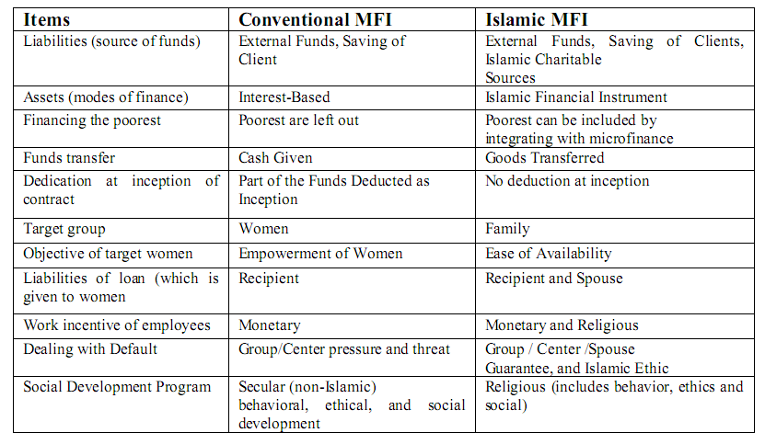

**Data analysis**

To explore the strengths and weaknesses of microfinance in Sudan, the model in the following table is proposed.

Table 5.2: SWOT analysis model

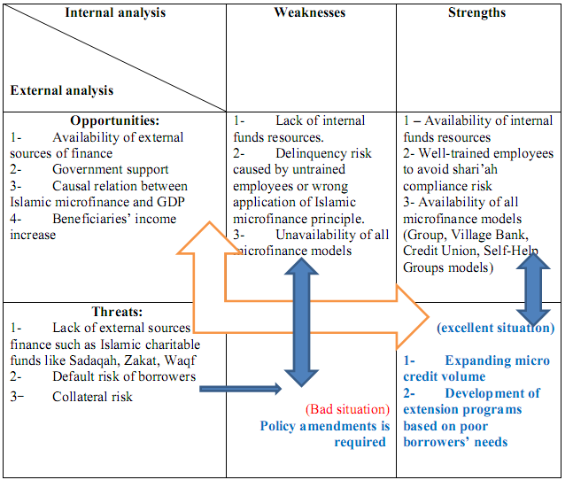

Source: Researcher

To find out the SWOT analysis results, a structured interview is developed and two types of questionnaires are distributed, one for microfinance banks’ employees and the other for beneficiaries of microfinance. Table 5.3 shows results from participants’ answers in the questionnaire.

**Table 5.3: Participants’ answers to questions in the questionnaire**

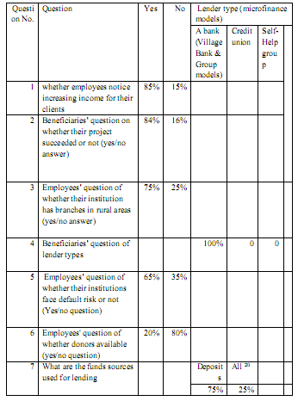



**Interviewees’ answers**

First, the researcher conducted an informal interview with the microfinance director in the Central Bank of Sudan. He said that village bank and credit union models were available in Sudan, but they planned to apply other models. Thus, not all microfinance models have been applied in the Sudan. Second, formal interviews were conducted with lenders (microfinance directors in lending banks). They mentioned the default percentage (average 18%) on microfinance loans. Thus, IMFIs face default risk. Also, they mentioned that there are four types of collateral, namely group collateral; un-allowed savings withdrawals; current asset collaterals; and gold collateral. Also, lenders’ interviewees mentioned that they suffer from shortage of funds sources, because they have strong competitors (commercial banks attract all big savings as current deposits). On whether employees in microfinance banks are trained to avoid delinquency risk, the interviewees answered that they trained employees to specialize in Islamic microfinance and that their banks have special shari’ah advisors and supervisors. Thus, there is no delinquency risk expected.

To find out the relation between IMF and GDP, linear regression test is made for the annual reports which cover the period 2011-2013.

Table 5.4: The causal relation between GDP and classification microfinance amount.

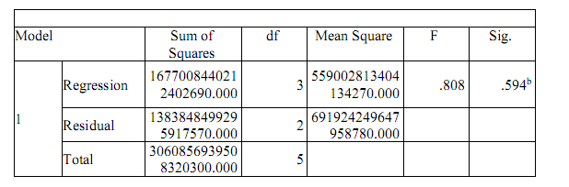



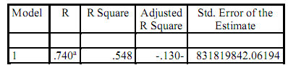

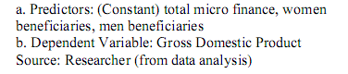

According Table 5.4, there is high estimation error, Islamic microfinance affects on GDP is about 54%, and other factors affect GDP by 46%. However, Table 5.5 shows insignificant relation.

**Table 5.5 shows insignificant causal relation between GDP and microfinance loans**

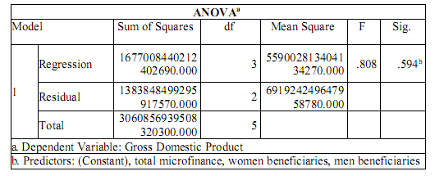



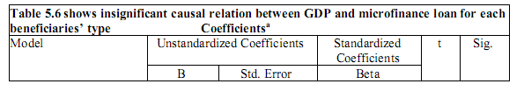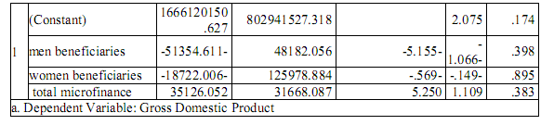



**Findings**

**Strength of Islamic microfinance in Sudan includes:**

Well-trained employees to apply Islamic microfinance principles.

**Weaknesses:**

1. Lack of internal fund resources

2. Unavailability of all microfinance models

**Opportunities:**

Lack of financial support from the government in credit policy, hence there is no external funds resources like big deposits, donors, and central bank financial support to microfinance banks. Thus, there are no opportunities to Islamic microfinance institutions in Sudan.

**Threats:**

1. Lack of external funds resources

2. Borrowers default risk

3. Insignificant relation between Islamic microfinance and Gross Domestic Product (GDP). Thus, Islamic microfinance in Sudan does not achieve its economic goal (social development as represented in GDP)

**Conclusion**

1. Islamic microfinance in Sudan requires amendment to the existing policy to reduce its weaknesses, and gain some features which can help it to achieve its economic goals.

2. Islamic microfinance slightly achieves its main goal (poverty alleviation represented in poor borrowers’ income increases).

**Recommendations**

1. Further studies on how microfinance institutions can overcome default risk

2. Further studies about applying all microfinance models in Sudan

3. Further studies about how microfinance can positively affect Gross Domestic Product.